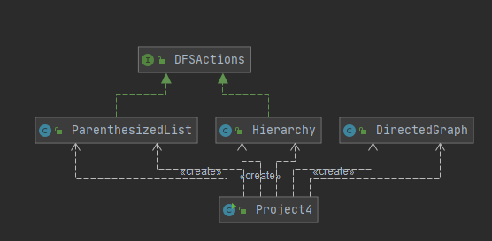

Unfortunately, at a lost on how to finish the rest of the program. I got it to create the fully linked graph, and check if there is a cycle dependency, but could not figure out the rest of the program in time for submission. Test case will just test what I have so far to ensure graphs are made and cycle is detected. I have it printing to console everything. The print does include edges that were never created as vertexes, I imagine this would have been something that would not occur with Hierarchy and ParenthesizedList if they were implemented correctly, or in this case at all.

Test case 1(Test if graphs are created and if cycle dependency is detected properly.)

|  |  |  |  |  |
| --- | --- | --- | --- | --- |
| Run: | Input | Expected Output | Actual Output | Pass/Fail |
| 1 | ClassA ClassC ClassE ClassJ  ClassB ClassD ClassG  ClassC ClassA  ClassE ClassB ClassF ClassH  ClassJ ClassB  ClassI ClassC | Cycle detected for ClassC | Cycle detected for ClassC  Prints all Vertexes and edges | Pass |
| 2 | Cas1 Cas2 Cas3  Cas2 Cas4 Cas5  Cas3 Cas7  Cas4 Cas9  Cas5 Cas4 | No cycle detected | No cycle detected  Prints all Vertexes and edges | Pass |
| 3 | ClassA ClassB ClassC  ClassE ClassC  ClassD ClassG ClassB  ClassB ClassA ClassZ ClassF | Cycle Detected for Class B | Cycle Detected for Class B  Prints all Vertexes and edges | Pass |

Screenshot run 3:

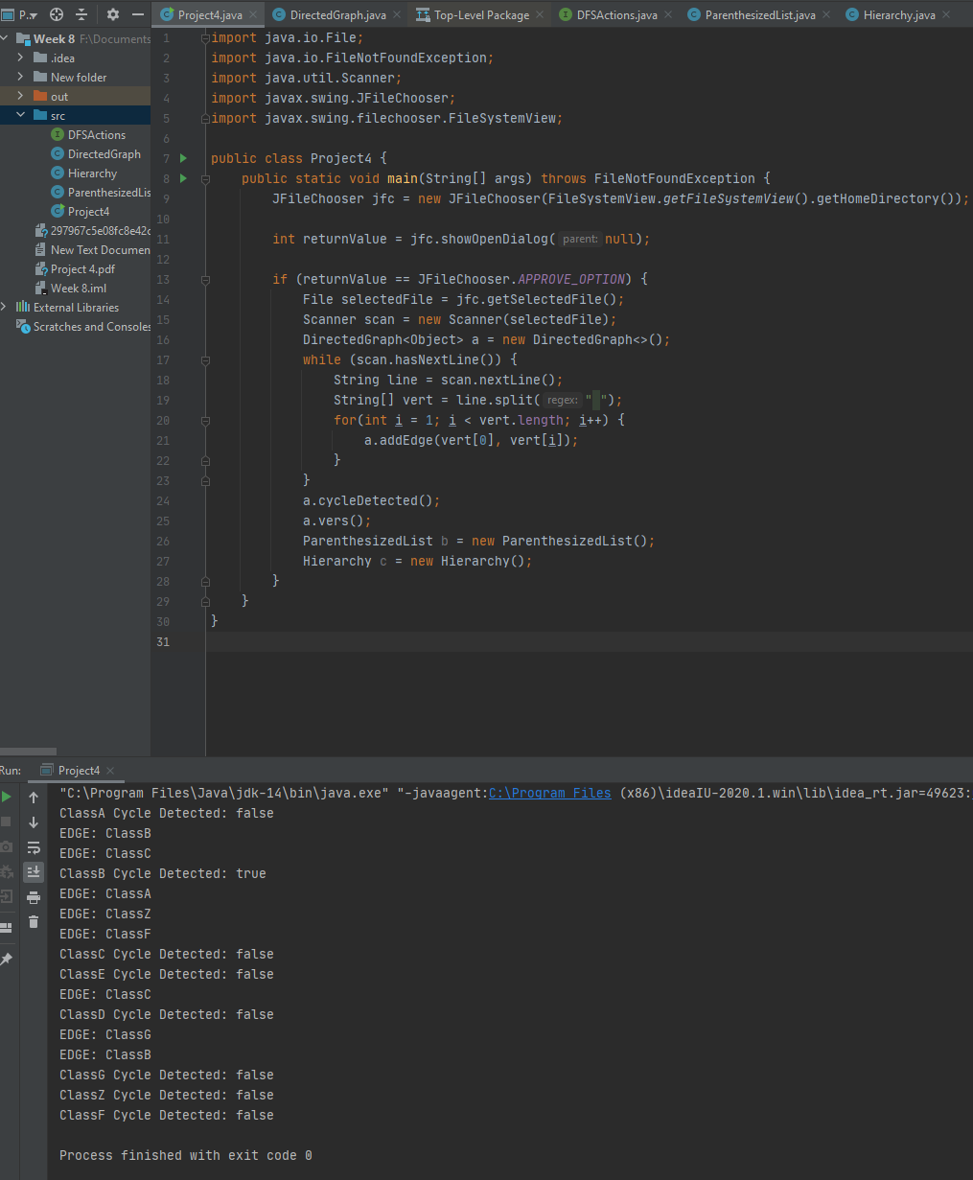

Lessons learned:

* I need to kick myself in gear and be at least a week ahead to prevent running out of time with online courses, this part of the semester was spent constantly finishing things last minute and it caught up. I thought I was in the clear and on track to finishing on time if I could just figure out the structure to create the alternatively linked adjacency list representation, but then realized I was not in the clear. The dfs search in directed graph threw me for a curveball along with getting it to print in the two forms required.
* Maybe watching videos on the topics covered in CS courses will help me get a better understanding of things and allow me to continue learning even when I am burned out from reading course materials.
* I hope you will accept my partially completed code and I hope that it is better than nothing. It pains me to turn the project in as it is, but I must leave soon and I am not sure if I would have made it much further if I had the rest of the day to finish it.